Voice Acting Information for:
Karen Kahler
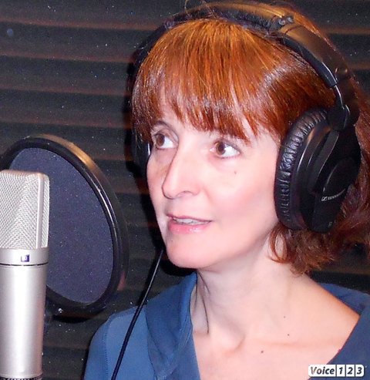

E-mail: karen@karenkahler.com
Website: http://www.karenkahler.com
Location: Southern California
Accents: Standard American, American Southern, British (RP, Cockney), Irish, Scottish, French, German, Eastern European
Bio: Karen’s eclectic career path passed through environmental consulting, seismic analysis, and science writing before arriving at acting. Her performances at the mic are informed by years of experience in classical and modern theater and independent film. She regards voice acting for video games as some of the most fun anyone can have without getting arrested. Visit http://karenkahler.nowcasting.com for a summary of Karen’s acting experience and http://karenkahler.voice123.com for more information about her voice work.
Feel free to contact Karen regarding voice acting for your projects!

